# Lesson 52 单词讲解

1. temporarily adv. 暂时地

do sth. temporarily

temporary adj. 暂时的，临时的，短期的

a temporary job

1. inch n. 英寸（度量单位）

12 inches = 1 foot（英尺）= 0.3048 metre

3 feet = 1 yard(码)

space [speis] n.空间

actually ['æktʃuəli] ad.实际上

# Lesson 52 课文&语法讲解

本课重点:

现在完成时

现在完成进行时

现在完成时

形式： have/has done

用法：现在的之前 强调事情完成的结果

现在完成进行时

形式： have/has been doing

用法：现在的之前 强调事情持续进行的过程

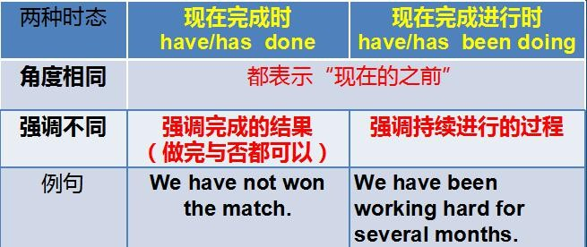

现在完成进行时

形式： have/has been doing

用法：现在的之前 强调事情持续进行的过程

I have been studying English all morning.

It has been raining for a week.

We have been living here since I was born.

1. We (move) into a new house

and I (work) hard all morning.

We have just moved into a new house

and I have been working hard all morning.

2.I (try) to get my new room in order.

I have been trying to get my new room in order.

try to do sth. get sth. in order

1. This has not been easy …（第四课）从过去到现在一直不容易，现在完成时描述的是俩时间段 过去到现在 过去时态描述的只是过去

This was not easy. This is not easy.

1. To make matters worse, the room is rather small, so I have temporarily put my books on the floor.

副词的位置比较灵活 可以放句尾

1. … and I actually have to walk on them to get in or out of the room.

Have to 必须 不得不做

1. A short while ago, my sister helped me to carry one of my old bookcases up the stairs.
2. 'This is the prettiest carpet I have ever seen,' …

It is one of the ugliest faces I have ever seen.

定语从句：以上两句只能用that做关系词 因为prettiest 比较级表示特指 只能用that

这个定语从句的作用：限定最高级的范围

… so it will soon be sending us the clearest pictures … that we have ever seen.

本课重点:

现在完成时

现在完成进行时

# Lesson 52 知识拓展

本课重点:

现在完成时 have/has + done

现在完成进行时 have/has been doing

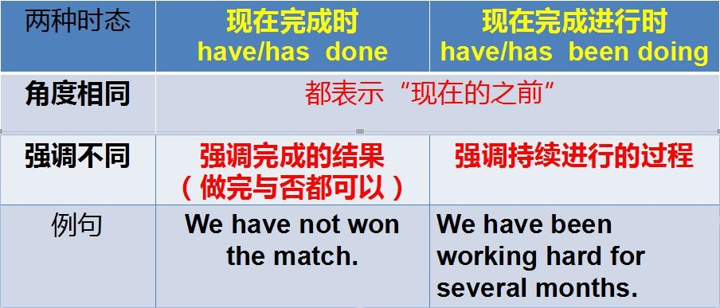

现在完成时／现在完成进行时

I (read) this chapter in my chemistry book three times, and I still don’t understand it!

have read

现在完成时／现在完成进行时

I (read) for two hours. I think I’ll take a break. have been reading

现在完成时／现在完成进行时

A: The baby (cry) for almost ten minutes.

B: Okay. I’ll go into his room and see if anything’s wrong. has been crying

现在完成时／现在完成进行时

I (stay) there at least a dozen times. It’s my favorite hotel. have stayed

本课重点:

现在完成时 have/has + done

现在完成进行时 have/has been doing

